Colour appearance
Suggestions for interpretations of Values under the new Feature "Colour appearance". The Feature "Colour appearance" is intended to be used on roof tiles, bricks, tiles etc. Example as below:
- EV000210 Fixed
- EVxxxxxx Gradient
- EV013007 Patchy (ex Bright)
- EV003822 Multi-coloured
- EV000154 Other

Fixed colour (roof tile)
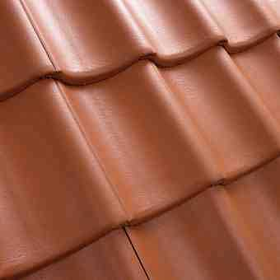

Gradient colour (roof tile)
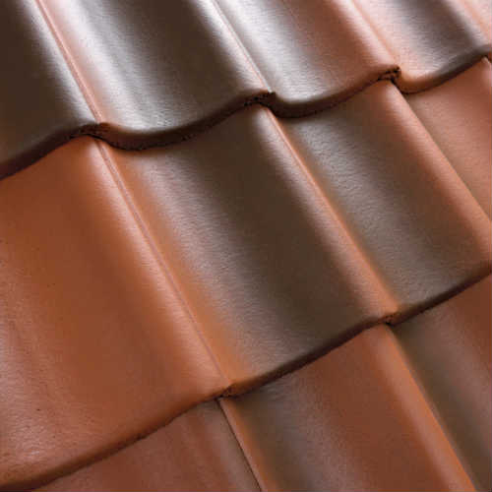

Fixed colour (brick)

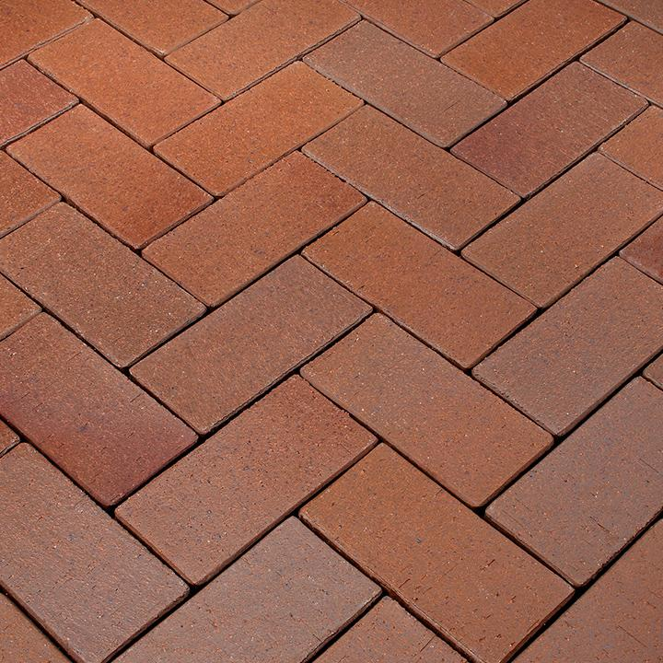

Gradient colour (brick)

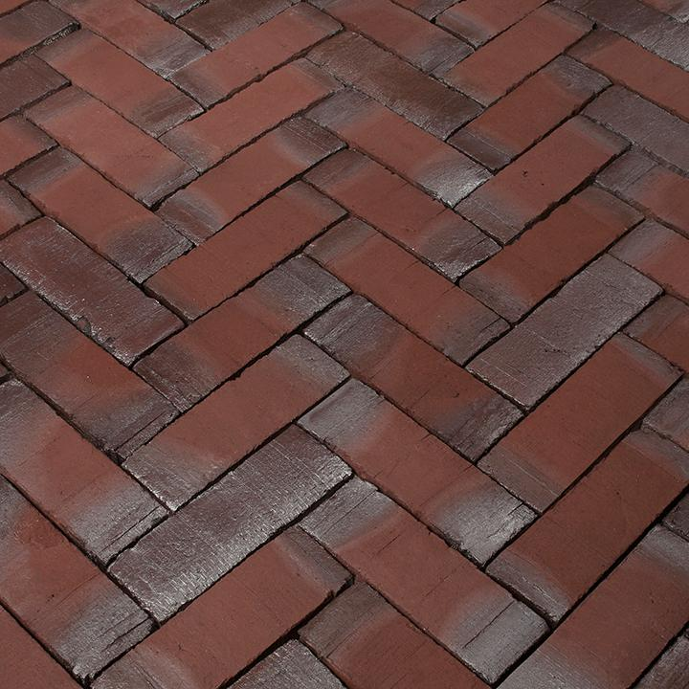

Multi-coloured (brick)

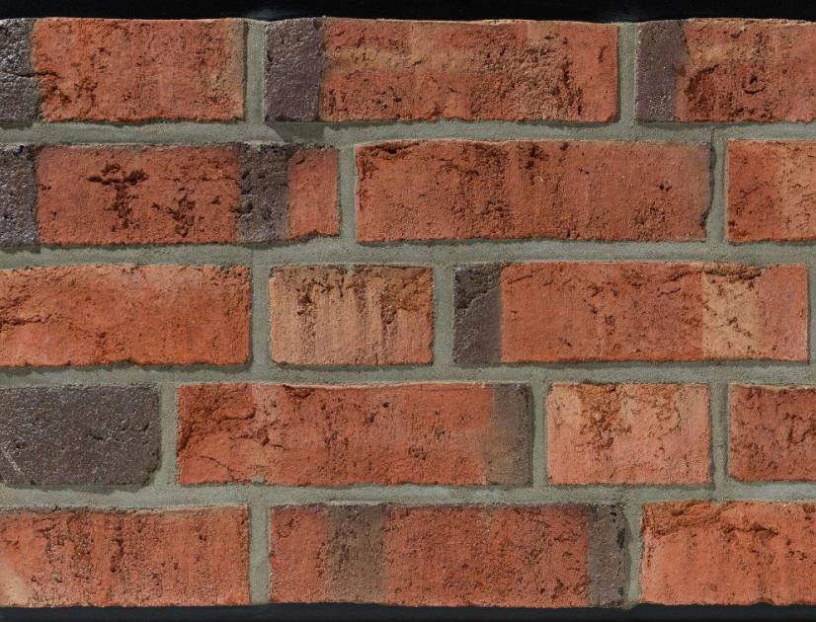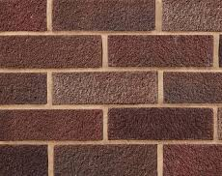

Patchy (brick)

Proposal on behalf of ETIM Sweden 2019-07-09
Christer Nordemo

branschkonsult.se
christer.nordemo@branschkonsult.se
www.branschkonsult.se

Lundkulla Produktion AB
Lundkulla Gård
SE-178 92 Adelsö
Sweden
+46 70 655 07 68

