Hi,

Did you know that The MrLangeveldPhoto Preset System also works very well on photos taken on a mobile phone camera? You can import your photos in Lightroom and give them exactly the edit you like. You can scroll through the different editing styles with different color tones (like Instagram Filters, but much more beautiful ). Darken or lighten the image, change highlights and shadows. Change contrast. Warm it up or cool it down. Make it more or less vibrant. Add lens correction, sharpen and add some noise reduction (if needed). And finish off with a vignette.
In a few clicks your photo is done and ready for export. Choose now for a small JPEG for multimedia or a large JPEG for storing on your hard drive or printing.
The next image was taken with an iPhone 6s, I edited in my MrLangeveldPhoto Preset System. In just a few clicks this was the result: Quiet nice isn’t it?

Edited in
Straight out of iPhone MrLangeveldPhoto Preset System
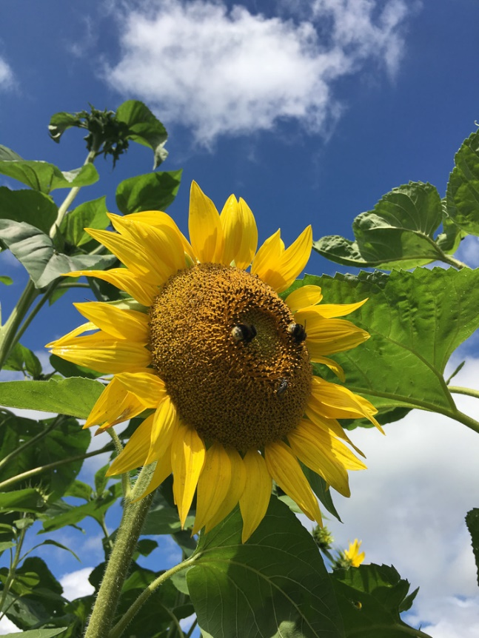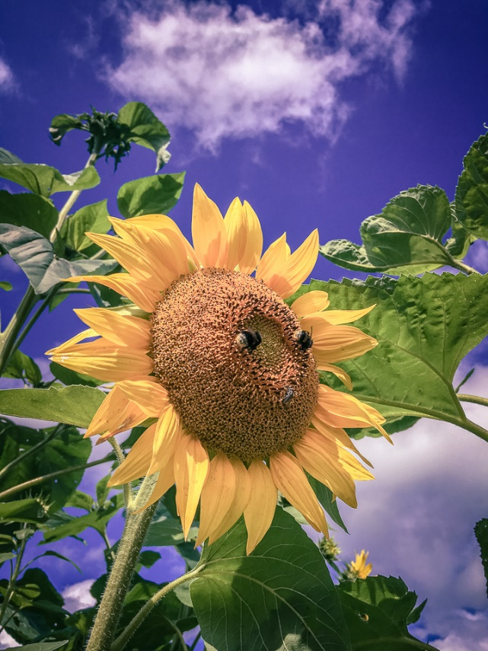

Download now this amazing system for this crazy introduction prize of 49,- US Dollar.
That’s 100,- US Dollar off the regular prize.
It's not only "one click presets" it's much more than that. It's a complete system that will fasten your workflow and your pictures will be perfect much faster.

Now only 49,- US Dollar regular price will be 149,- US Dollar soon.
download here:
Talk soon,
Jeroen (MrLangeveldPhoto)

